Course: CS631 - 003

Professor: Dimitri Theodoratos

Group #6: Chaitanya Prabhakar Ghadling,

Deep Patel,

Shanmuga Sankar Balamurugan

Subject: Project Deliverable 3

Topic: The City Library Database

**CITY LIBRARY DATABASE PROJECT DELIVERABLE 3**

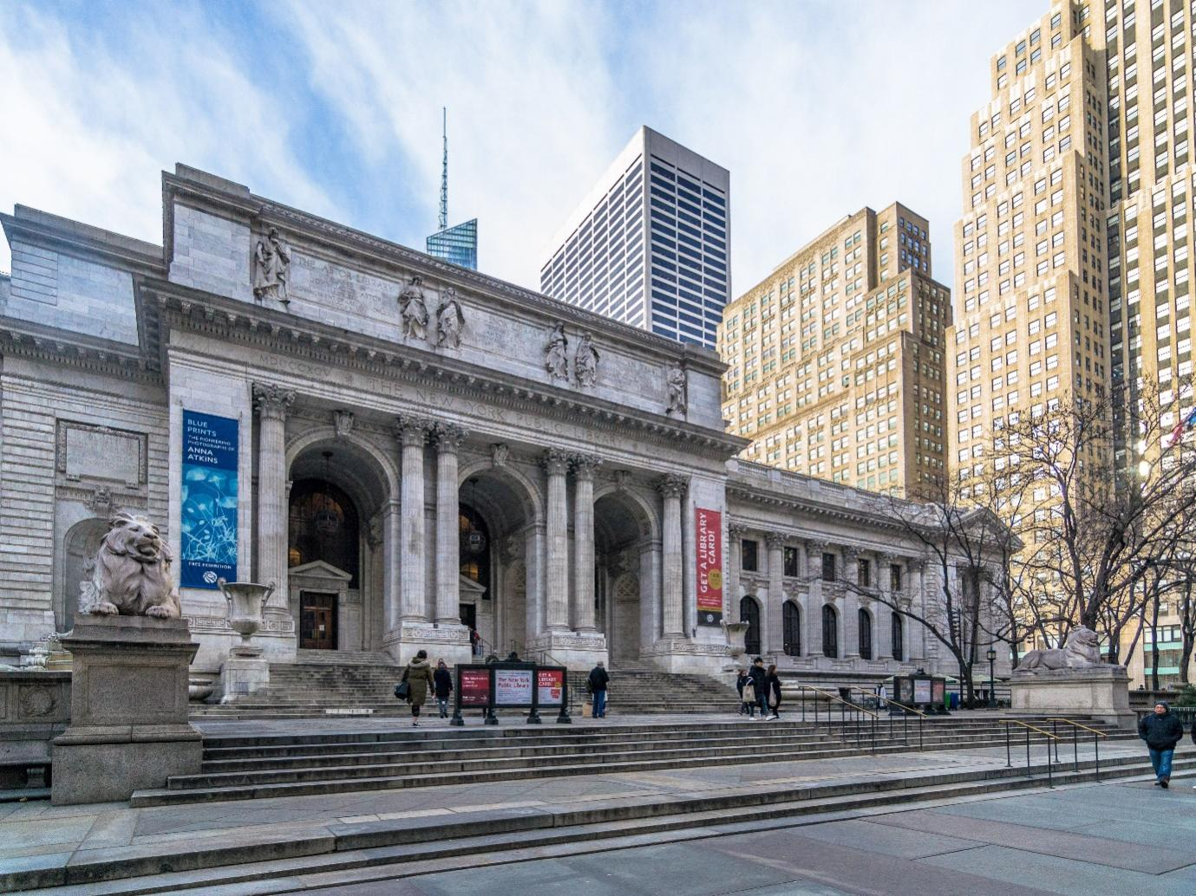

* We have created a menu driven command line interface on Python.
* Used MySQL as database and used MYSQL workbench for database administration.
* All the reader and administrator tasks have been implemented.
* The reader is authorized using Reader ID while we have added few admin login details in the database for admin authorization.

**DATABASE CREATION:**

1. **Person table**

CREATE TABLE `librarydatabase`.`person` (

`pid` INT NOT NULL,

`pname` VARCHAR(45) NULL,

PRIMARY KEY (`pid`));

1. **Publisher table**

CREATE TABLE `librarydatabase`.`publisher` (

`publisherid` INT NOT NULL,

`pubname` VARCHAR(45) NULL,

`address` VARCHAR(145) NULL,

PRIMARY KEY (`publisherid`));

1. **Branch table**

CREATE TABLE `librarydatabase`.`branch` (

`bid` INT NOT NULL,

`lname` VARCHAR(45) NULL,

`location` VARCHAR(45) NULL,

PRIMARY KEY (`bid`));

1. **Reservation table**

CREATE TABLE `librarydatabase`.`reservation` (

`res_no` INT NOT NULL,

`dtime` DATETIME NULL,

PRIMARY KEY (`res_no`));

1. **Reader table**

CREATE TABLE `librarydatabase`.`reader` (

`rid` INT NOT NULL,

`rtype` VARCHAR(45) NULL,

`rname` VARCHAR(45) NULL,

`raddress` VARCHAR(45) NULL,

`phone_no` VARCHAR(45) NULL,

PRIMARY KEY (`rid`));

1. **Borrowing table**

CREATE TABLE `librarydatabase`.`borrowing` (

`bor_no` INT NOT NULL,

`bdtime` DATETIME NULL,

`rdtime` DATETIME NULL,

PRIMARY KEY (`bor_no`));

1. **Document table**

CREATE TABLE `librarydatabase`.`document` (

`docid` INT NOT NULL,

`title` VARCHAR(45) NULL,

`pdate` DATETIME NULL,

`publisherid` INT NULL,

PRIMARY KEY (`docid`),

INDEX `publisherid_idx` (`publisherid` ASC) VISIBLE,

CONSTRAINT `publisherid`

FOREIGN KEY (`publisherid`)

REFERENCES `librarydatabase`.`publisher` (`publisherid`)

ON DELETE RESTRICT

ON UPDATE RESTRICT);

1. **Book table**

CREATE TABLE `librarydatabase`.`book` (

`docid` INT NOT NULL,

`isbn` VARCHAR(45) NULL,

PRIMARY KEY (`docid`),

CONSTRAINT `docid`

FOREIGN KEY (`docid`)

REFERENCES `librarydatabase`.`document` (`docid`)

ON DELETE RESTRICT

ON UPDATE RESTRICT);

1. **Journal volume**

CREATE TABLE `librarydatabase`.`journal_volume` (

`docid` INT NOT NULL,

`volume_no` INT NULL,

`editor` INT NULL,

PRIMARY KEY (`docid`),

INDEX `editor_idx` (`editor` ASC) VISIBLE,

CONSTRAINT `j_docid`

FOREIGN KEY (`docid`)

REFERENCES `librarydatabase`.`document` (`docid`)

ON DELETE RESTRICT

ON UPDATE RESTRICT,

CONSTRAINT `editor`

FOREIGN KEY (`editor`)

REFERENCES `librarydatabase`.`person` (`pid`)

ON DELETE RESTRICT

ON UPDATE RESTRICT);

1. **Proceedings table**

CREATE TABLE `librarydatabase`.`proceedings` (

`docid` INT NOT NULL,

`cdate` DATE NULL,

`clocation` VARCHAR(45) NULL,

`ceditor` VARCHAR(45) NULL,

PRIMARY KEY (`docid`),

CONSTRAINT `p_docid`

FOREIGN KEY (`docid`)

REFERENCES `librarydatabase`.`document` (`docid`)

ON DELETE RESTRICT

ON UPDATE RESTRICT);

1. **Authors table**

CREATE TABLE `librarydatabase`.`authors` (

`pid` INT NOT NULL,

`docid` INT NOT NULL,

PRIMARY KEY (`pid`, `docid`),

INDEX `a_docid_idx` (`docid` ASC) VISIBLE,

CONSTRAINT `a_pid`

FOREIGN KEY (`pid`)

REFERENCES `librarydatabase`.`person` (`pid`)

ON DELETE RESTRICT

ON UPDATE RESTRICT,

CONSTRAINT `a_docid`

FOREIGN KEY (`docid`)

REFERENCES `librarydatabase`.`document` (`docid`)

ON DELETE RESTRICT

ON UPDATE RESTRICT);

1. **Journal issue table**

CREATE TABLE `librarydatabase`.`journal_issue` (

`docid` INT NOT NULL,

`issue_no` VARCHAR(45) NOT NULL,

`scope` VARCHAR(45) NULL,

PRIMARY KEY (`docid`, `issue_no`),

CONSTRAINT `ji_docid`

FOREIGN KEY (`docid`)

REFERENCES `librarydatabase`.`journal_volume` (`docid`)

ON DELETE RESTRICT

ON UPDATE RESTRICT);

1. **Gedits table**

CREATE TABLE `librarydatabase`.`gedits` (

`docid` INT NOT NULL,

`issue_no` VARCHAR(45) NOT NULL,

`pid` INT NOT NULL,

PRIMARY KEY (`docid`, `issue_no`, `pid`),

INDEX `g_pid_idx` (`pid` ASC) VISIBLE,

CONSTRAINT `g_ji_doc`

FOREIGN KEY (`docid` , `issue_no`)

REFERENCES `librarydatabase`.`journal_issue` (`docid` , `issue_no`)

ON DELETE RESTRICT

ON UPDATE RESTRICT,

CONSTRAINT `g_pid`

FOREIGN KEY (`pid`)

REFERENCES `librarydatabase`.`person` (`pid`)

ON DELETE RESTRICT

ON UPDATE RESTRICT);

1. **Chairs table**

CREATE TABLE `librarydatabase`.`chairs` (

`pid` INT NOT NULL,

`docid` INT NOT NULL,

PRIMARY KEY (`pid`, `docid`),

INDEX `c_docid_idx` (`docid` ASC) VISIBLE,

CONSTRAINT `c_pid`

FOREIGN KEY (`pid`)

REFERENCES `librarydatabase`.`person` (`pid`)

ON DELETE RESTRICT

ON UPDATE RESTRICT,

CONSTRAINT `c_docid`

FOREIGN KEY (`docid`)

REFERENCES `librarydatabase`.`proceedings` (`docid`)

ON DELETE RESTRICT

ON UPDATE RESTRICT);

1. **Copy table**

CREATE TABLE `librarydatabase`.`copy` (

`docid` INT NOT NULL,

`copyno` INT NOT NULL,

`bid` INT NOT NULL,

`position` VARCHAR(45) NULL,

PRIMARY KEY (`docid`, `copyno`, `bid`),

INDEX `cy_bid_idx` (`bid` ASC) VISIBLE,

CONSTRAINT `cy_bid`

FOREIGN KEY (`bid`)

REFERENCES `librarydatabase`.`branch` (`bid`)

ON DELETE RESTRICT

ON UPDATE RESTRICT,

CONSTRAINT `cy_docid`

FOREIGN KEY (`docid`)

REFERENCES `librarydatabase`.`document` (`docid`)

ON DELETE RESTRICT

ON UPDATE RESTRICT);

1. **Borrows table**

CREATE TABLE `librarydatabase`.`borrows` (

`bor_no` INT NOT NULL,

`docid` INT NOT NULL,

`copyno` INT NOT NULL,

`bid` INT NOT NULL,

`rid` INT NULL,

`status` varchar(45) DEFAULT 'ACTIVE'

PRIMARY KEY (`bor_no`, `bid`, `copyno`, `docid`),

INDEX `b_copy_idx` (`docid` ASC, `copyno` ASC, `bid` ASC) VISIBLE,

INDEX `b_rid_idx` (`rid` ASC) VISIBLE,

CONSTRAINT `bor_no`

FOREIGN KEY (`bor_no`)

REFERENCES `librarydatabase`.`borrowing` (`bor_no`)

ON DELETE RESTRICT

ON UPDATE RESTRICT,

CONSTRAINT `b_copy`

FOREIGN KEY (`docid` , `copyno` , `bid`)

REFERENCES `librarydatabase`.`copy` (`docid` , `copyno` , `bid`)

ON DELETE RESTRICT

ON UPDATE RESTRICT,

CONSTRAINT `b_rid`

FOREIGN KEY (`rid`)

REFERENCES `librarydatabase`.`reader` (`rid`)

ON DELETE RESTRICT

ON UPDATE RESTRICT);

1. **Reserves table**

CREATE TABLE `librarydatabase`.`reserves` (

`rid` INT NULL,

`reservation_no` INT NOT NULL,

`docid` INT NOT NULL,

`copyno` INT NOT NULL,

`bid` INT NOT NULL,

PRIMARY KEY (`reservation_no`, `docid`, `copyno`, `bid`),

INDEX `r_rid_idx` (`rid` ASC) VISIBLE,

INDEX `r_copy_idx` (`docid` ASC, `copyno` ASC, `bid` ASC) VISIBLE,

CONSTRAINT `r_rid`

FOREIGN KEY (`rid`)

REFERENCES `librarydatabase`.`reader` (`rid`)

ON DELETE RESTRICT

ON UPDATE RESTRICT,

CONSTRAINT `r_res`

FOREIGN KEY (`reservation_no`)

REFERENCES `librarydatabase`.`reservation` (`res_no`)

ON DELETE RESTRICT

ON UPDATE RESTRICT,

CONSTRAINT `r_copy`

FOREIGN KEY (`docid` , `copyno` , `bid`)

REFERENCES `librarydatabase`.`copy` (`docid` , `copyno` , `bid`)

ON DELETE RESTRICT

ON UPDATE RESTRICT);

1. **Admin_login**

CREATE TABLE `librarydatabase`.`admin_login` (

`admin_id` VARCHAR(45) NOT NULL,

`password` VARCHAR(45) NULL,

PRIMARY KEY (`admin_id`));

Data Insertion.

1. **Admin_Login**

INSERT INTO `librarydatabase`.`admin_login` (`admin_id`, `password`) VALUES ('shankar', '1234');

INSERT INTO `librarydatabase`.`admin_login` (`admin_id`, `password`) VALUES ('chaitanya', '9876');

INSERT INTO `librarydatabase`.`admin_login` (`admin_id`, `password`) VALUES ('deep', '4567');

1. **Person**

INSERT INTO `librarydatabase`.`person` (`pid`, `pname`) VALUES ('1', 'Deep');

INSERT INTO `librarydatabase`.`person` (`pid`, `pname`) VALUES ('2', 'Chaitanya');

INSERT INTO `librarydatabase`.`person` (`pid`, `pname`) VALUES ('3', 'Shankar');

INSERT INTO `librarydatabase`.`person` (`pid`, `pname`) VALUES ('4', 'Rohan');

INSERT INTO `librarydatabase`.`person` (`pid`, `pname`) VALUES ('5', 'Rishabh');

INSERT INTO `librarydatabase`.`person` (`pid`, `pname`) VALUES ('6', 'Partha');

INSERT INTO `librarydatabase`.`person` (`pid`, `pname`) VALUES ('7', 'Monil');

INSERT INTO `librarydatabase`.`person` (`pid`, `pname`) VALUES ('8', 'Chirag');

INSERT INTO `librarydatabase`.`person` (`pid`, `pname`) VALUES ('9', 'Akshit');

INSERT INTO `librarydatabase`.`person` (`pid`, `pname`) VALUES ('10', 'Zal');

INSERT INTO `librarydatabase`.`person` (`pid`, `pname`) VALUES ('11', 'Saya');

1. **Publisher**

INSERT INTO `librarydatabase`.`publisher` (`publisherid`, `pubname`, `address`) VALUES ('102', 'Google', 'pa, usa');

INSERT INTO `librarydatabase`.`publisher` (`publisherid`, `pubname`, `address`) VALUES ('103', 'Microsoft', 'ny, usa');

INSERT INTO `librarydatabase`.`publisher` (`publisherid`, `pubname`, `address`) VALUES ('104', 'Lenscart', 'az, usa ');

INSERT INTO `librarydatabase`.`publisher` (`publisherid`, `pubname`, `address`) VALUES ('105', 'Tesla', 'ca, usa ');

INSERT INTO `librarydatabase`.`publisher` (`publisherid`, `pubname`, `address`) VALUES ('106', 'TCS', 'il, usa');

INSERT INTO `librarydatabase`.`publisher` (`publisherid`, `pubname`, `address`) VALUES ('107', 'Kohls', 'na,usa');

INSERT INTO `librarydatabase`.`publisher` (`publisherid`, `pubname`, `address`) VALUES ('108', 'Fossil', 'va, usa');

INSERT INTO `librarydatabase`.`publisher` (`publisherid`, `pubname`, `address`) VALUES ('109', 'BMW', 'vt, usa');

INSERT INTO `librarydatabase`.`publisher` (`publisherid`, `pubname`, `address`) VALUES ('110', 'Audi', 'oh, usa');

INSERT INTO `librarydatabase`.`publisher` (`publisherid`, `pubname`) VALUES ('111', 'Nike');

UPDATE `librarydatabase`.`publisher` SET `pubname` = 'Amazon', `address` = 'nj, usa' WHERE (`publisherid` = '101');

1. **Document**

INSERT INTO `librarydatabase`.`document` (`docid`, `title`, `pdate`, `publisherid`) VALUES ('22', 'Hello', '2022-12-7', '102');

INSERT INTO `librarydatabase`.`document` (`docid`, `title`, `pdate`, `publisherid`) VALUES ('23', 'Kem ', '2022-12-8', '103');

INSERT INTO `librarydatabase`.`document` (`docid`, `title`, `pdate`, `publisherid`) VALUES ('24', 'Party', '2022-12-9', '104');

INSERT INTO `librarydatabase`.`document` (`docid`, `title`, `pdate`, `publisherid`) VALUES ('25', 'Su ', '2022-12-10', '105');

INSERT INTO `librarydatabase`.`document` (`docid`, `title`, `pdate`, `publisherid`) VALUES ('26', 'Chale', '2022-12-11', '106');

INSERT INTO `librarydatabase`.`document` (`docid`, `title`, `pdate`, `publisherid`) VALUES ('27', 'Setting', '2022-12-12', '107');

INSERT INTO `librarydatabase`.`document` (`docid`, `title`, `pdate`, `publisherid`) VALUES ('28', 'Maal', '2022-12-13', '108');

INSERT INTO `librarydatabase`.`document` (`docid`, `title`, `pdate`, `publisherid`) VALUES ('29', 'Pani', '2022-12-14', '109');

INSERT INTO `librarydatabase`.`document` (`docid`, `title`, `pdate`, `publisherid`) VALUES ('30', 'Kevu', '2022-12-15', '110');

INSERT INTO `librarydatabase`.`document` (`docid`, `title`, `pdate`, `publisherid`) VALUES ('31', 'Badhu', '2022-12-16', '111');

UPDATE `librarydatabase`.`document` SET `title` = 'Hi', `pdate` = '2022-12-6' WHERE (`docid` = '21');

1. **Branch**

INSERT INTO `librarydatabase`.`branch` (`bid`, `lname`, `location`) VALUES ('51', 'Patel', 'NJ');

INSERT INTO `librarydatabase`.`branch` (`bid`, `lname`, `location`) VALUES ('52', 'Shah', 'CA');

INSERT INTO `librarydatabase`.`branch` (`bid`, `lname`, `location`) VALUES ('53', 'Patel', 'NY');

INSERT INTO `librarydatabase`.`branch` (`bid`, `lname`, `location`) VALUES ('54', 'Joshi', 'OH');

INSERT INTO `librarydatabase`.`branch` (`bid`, `lname`, `location`) VALUES ('55', 'Parekh', 'VA');

INSERT INTO `librarydatabase`.`branch` (`bid`, `lname`, `location`) VALUES ('56', 'Shah', 'DC');

INSERT INTO `librarydatabase`.`branch` (`bid`, `lname`, `location`) VALUES ('57', 'Thakkar', 'NJ');

INSERT INTO `librarydatabase`.`branch` (`bid`, `lname`, `location`) VALUES ('58', 'Ghadling', 'NY');

INSERT INTO `librarydatabase`.`branch` (`bid`, `lname`, `location`) VALUES ('59', 'Ali', 'OH');

INSERT INTO `librarydatabase`.`branch` (`bid`, `lname`, `location`) VALUES ('60', 'Kohli', 'VA');

INSERT INTO `librarydatabase`.`branch` (`bid`, `lname`, `location`) VALUES ('61', 'Sharma', 'OH');

1. **Reader**

INSERT INTO `librarydatabase`.`reader` (`rid`, `rtype`, `rname`, `raddress`, `phone_no`) VALUES ('71', 'staff', 'Jill', 'CA', '1234567891');

INSERT INTO `librarydatabase`.`reader` (`rid`, `rtype`, `rname`, `raddress`, `phone_no`) VALUES ('72', 'student', 'Jack', 'IL', '2233445566');

INSERT INTO `librarydatabase`.`reader` (`rid`, `rtype`, `rname`, `raddress`, `phone_no`) VALUES ('73', 'senior citizen', 'Rick', 'NJ', '7766887766');

INSERT INTO `librarydatabase`.`reader` (`rid`, `rtype`, `rname`, `raddress`, `phone_no`) VALUES ('74', 'staff', 'Jhon', 'VA', '1166772233');

INSERT INTO `librarydatabase`.`reader` (`rid`, `rtype`, `rname`, `raddress`, `phone_no`) VALUES ('75', 'senior citizen', 'Sam', 'DC', '9988776655');

INSERT INTO `librarydatabase`.`reader` (`rid`, `rtype`, `rname`, `raddress`, `phone_no`) VALUES ('76', 'staff', 'Ron', 'OH', '6644221199');

INSERT INTO `librarydatabase`.`reader` (`rid`, `rtype`, `rname`, `raddress`, `phone_no`) VALUES ('77', 'senior citizen', 'Cape', 'NY', '5533008855');

INSERT INTO `librarydatabase`.`reader` (`rid`, `rtype`, `rname`, `raddress`, `phone_no`) VALUES ('78', 'student', 'Xi', 'SF', '5566338822');

INSERT INTO `librarydatabase`.`reader` (`rid`, `rtype`, `rname`, `raddress`, `phone_no`) VALUES ('79', 'senior citizen', 'Donald', 'MS', '7745372898');

INSERT INTO `librarydatabase`.`reader` (`rid`, `rtype`, `rname`, `raddress`, `phone_no`) VALUES ('80', 'student', 'Ro', 'NJ', '1235787654');

INSERT INTO `librarydatabase`.`reader` (`rid`, `rtype`, `rname`, `raddress`, `phone_no`) VALUES ('81', 'senior citizen', 'Pinky', 'NY', '2345678652');

1. **Reservation**

INSERT INTO `librarydatabase`.`reservation` (`res_no`, `dtime`) VALUES ('201', '2022-11-01');

INSERT INTO `librarydatabase`.`reservation` (`res_no`, `dtime`) VALUES ('202', '2022-11-02');

INSERT INTO `librarydatabase`.`reservation` (`res_no`, `dtime`) VALUES ('203', '2022-11-03');

INSERT INTO `librarydatabase`.`reservation` (`res_no`, `dtime`) VALUES ('204', '2022-11-04');

INSERT INTO `librarydatabase`.`reservation` (`res_no`, `dtime`) VALUES ('205', '2022-11-05');

INSERT INTO `librarydatabase`.`reservation` (`res_no`, `dtime`) VALUES ('206', '2022-11-06');

INSERT INTO `librarydatabase`.`reservation` (`res_no`, `dtime`) VALUES ('207', '2022-11-07');

INSERT INTO `librarydatabase`.`reservation` (`res_no`, `dtime`) VALUES ('208', '2022-11-08');

INSERT INTO `librarydatabase`.`reservation` (`res_no`, `dtime`) VALUES ('209', '2022-11-09');

INSERT INTO `librarydatabase`.`reservation` (`res_no`, `dtime`) VALUES ('210', '2022-11-10');

INSERT INTO `librarydatabase`.`reservation` (`res_no`, `dtime`) VALUES ('211', '2022-11-11');

1. **Borrowing**

INSERT INTO `librarydatabase`.`borrowing` (`bor_no`, `bdtime`, `rdtime`) VALUES ('251', '2022-10-01', '2022-10-11');

INSERT INTO `librarydatabase`.`borrowing` (`bor_no`, `bdtime`, `rdtime`) VALUES ('252', '2022-10-02', '2022-10-17');

INSERT INTO `librarydatabase`.`borrowing` (`bor_no`, `bdtime`, `rdtime`) VALUES ('253', '2022-10-03', '2022-10-18');

INSERT INTO `librarydatabase`.`borrowing` (`bor_no`, `bdtime`, `rdtime`) VALUES ('254', '2022-10-04', '2022-10-09');

INSERT INTO `librarydatabase`.`borrowing` (`bor_no`, `bdtime`) VALUES ('255', '2022-10-05');

INSERT INTO `librarydatabase`.`borrowing` (`bor_no`, `bdtime`, `rdtime`) VALUES ('256', '2022-10-06', '2022-10-17');

INSERT INTO `librarydatabase`.`borrowing` (`bor_no`, `bdtime`, `rdtime`) VALUES ('257', '2022-10-07', '2022-10-10');

INSERT INTO `librarydatabase`.`borrowing` (`bor_no`, `bdtime`, `rdtime`) VALUES ('258', '2022-10-08', '2022-10-12');

INSERT INTO `librarydatabase`.`borrowing` (`bor_no`, `bdtime`, `rdtime`) VALUES ('259', '2022-10-09', '2022-10-25');

INSERT INTO `librarydatabase`.`borrowing` (`bor_no`, `bdtime`) VALUES ('260', '2022-10-10');

INSERT INTO `librarydatabase`.`borrowing` (`bor_no`, `bdtime`, `rdtime`) VALUES ('261', '2022-10-11', '2022-10-23');

1. **Copy**

INSERT INTO `librarydatabase`.`copy` (`docid`, `copyno`, `bid`, `position`) VALUES ('21', '1001', '51', '001A03');

INSERT INTO `librarydatabase`.`copy` (`docid`, `copyno`, `bid`, `position`) VALUES ('22', '1002', '52', '002B04');

INSERT INTO `librarydatabase`.`copy` (`docid`, `copyno`, `bid`, `position`) VALUES ('23', '1003', '53', '001B02');

INSERT INTO `librarydatabase`.`copy` (`docid`, `copyno`, `bid`, `position`) VALUES ('24', '1004', '54', '003C02');

INSERT INTO `librarydatabase`.`copy` (`docid`, `copyno`, `bid`, `position`) VALUES ('25', '1005', '55', '001A05');

INSERT INTO `librarydatabase`.`copy` (`docid`, `copyno`, `bid`, `position`) VALUES ('26', '1006', '56', '002A06');

INSERT INTO `librarydatabase`.`copy` (`docid`, `copyno`, `bid`, `position`) VALUES ('27', '1007', '57', '003C01');

INSERT INTO `librarydatabase`.`copy` (`docid`, `copyno`, `bid`, `position`) VALUES ('28', '1008', '58', '001A04');

INSERT INTO `librarydatabase`.`copy` (`docid`, `copyno`, `bid`, `position`) VALUES ('29', '1009', '59', '001A07');

INSERT INTO `librarydatabase`.`copy` (`docid`, `copyno`, `bid`, `position`) VALUES ('30', '1010', '60', '002B03');

INSERT INTO `librarydatabase`.`copy` (`docid`, `copyno`, `bid`, `position`) VALUES ('31', '1011', '61', '001B04');

1. **Reserves**

INSERT INTO `librarydatabase`.`reserves` (`rid`, `reservation_no`, `docid`, `copyno`, `bid`) VALUES ('71', '201', '21', '1001', '51');

INSERT INTO `librarydatabase`.`reserves` (`rid`, `reservation_no`, `docid`, `copyno`, `bid`) VALUES ('72', '202', '22', '1002', '52');

INSERT INTO `librarydatabase`.`reserves` (`rid`, `reservation_no`, `docid`, `copyno`, `bid`) VALUES ('73', '203', '23', '1003', '53');

INSERT INTO `librarydatabase`.`reserves` (`rid`, `reservation_no`, `docid`, `copyno`, `bid`) VALUES ('74', '204', '24', '1004', '54');

INSERT INTO `librarydatabase`.`reserves` (`rid`, `reservation_no`, `docid`, `copyno`, `bid`) VALUES ('75', '205', '25', '1005', '55');

INSERT INTO `librarydatabase`.`reserves` (`rid`, `reservation_no`, `docid`, `copyno`, `bid`) VALUES ('76', '206', '26', '1006', '56');

INSERT INTO `librarydatabase`.`reserves` (`rid`, `reservation_no`, `docid`, `copyno`, `bid`) VALUES ('77', '207', '27', '1007', '57');

INSERT INTO `librarydatabase`.`reserves` (`rid`, `reservation_no`, `docid`, `copyno`, `bid`) VALUES ('78', '208', '28', '1008', '58');

INSERT INTO `librarydatabase`.`reserves` (`rid`, `reservation_no`, `docid`, `copyno`, `bid`) VALUES ('79', '209', '29', '1009', '59');

INSERT INTO `librarydatabase`.`reserves` (`rid`, `reservation_no`, `docid`, `copyno`, `bid`) VALUES ('80', '210', '30', '1010', '60');

INSERT INTO `librarydatabase`.`reserves` (`rid`, `reservation_no`, `docid`, `copyno`, `bid`) VALUES ('81', '211', '31', '1011', '61');

1. **Borrow**

INSERT INTO `librarydatabase`.`borrows` (`bor_no`, `docid`, `copyno`, `bid`, `rid`) VALUES ('251', '21', '1001', '51', '71');

INSERT INTO `librarydatabase`.`borrows` (`bor_no`, `docid`, `copyno`, `bid`, `rid`) VALUES ('252', '22', '1002', '52', '72');

INSERT INTO `librarydatabase`.`borrows` (`bor_no`, `docid`, `copyno`, `bid`, `rid`) VALUES ('253', '23', '1003', '53', '73');

INSERT INTO `librarydatabase`.`borrows` (`bor_no`, `docid`, `copyno`, `bid`, `rid`) VALUES ('254', '24', '1004', '54', '74');

INSERT INTO `librarydatabase`.`borrows` (`bor_no`, `docid`, `copyno`, `bid`, `rid`) VALUES ('255', '25', '1005', '55', '75');

INSERT INTO `librarydatabase`.`borrows` (`bor_no`, `docid`, `copyno`, `bid`, `rid`) VALUES ('256', '26', '1006', '56', '76');

INSERT INTO `librarydatabase`.`borrows` (`bor_no`, `docid`, `copyno`, `bid`, `rid`) VALUES ('257', '27', '1007', '57', '77');

INSERT INTO `librarydatabase`.`borrows` (`bor_no`, `docid`, `copyno`, `bid`, `rid`) VALUES ('258', '28', '1008', '58', '78');

INSERT INTO `librarydatabase`.`borrows` (`bor_no`, `docid`, `copyno`, `bid`, `rid`) VALUES ('259', '29', '1009', '59', '79');

INSERT INTO `librarydatabase`.`borrows` (`bor_no`, `docid`, `copyno`, `bid`, `rid`) VALUES ('260', '30', '1010', '60', '80');

INSERT INTO `librarydatabase`.`borrows` (`bor_no`, `docid`, `copyno`, `bid`, `rid`) VALUES ('261', '31', '1011', '61', '81');

1. **Book**

INSERT INTO `librarydatabase`.`book` (`docid`, `isbn`) VALUES ('21', '2001');

INSERT INTO `librarydatabase`.`book` (`docid`, `isbn`) VALUES ('22', '2002');

INSERT INTO `librarydatabase`.`book` (`docid`, `isbn`) VALUES ('23', '2003');

INSERT INTO `librarydatabase`.`book` (`docid`, `isbn`) VALUES ('24', '2004');

1. **Journal_Volume**

INSERT INTO `librarydatabase`.`journal_volume` (`docid`, `volume_no`, `editor`) VALUES ('25', '1', '2');

INSERT INTO `librarydatabase`.`journal_volume` (`docid`, `volume_no`, `editor`) VALUES ('26', '2', '4');

INSERT INTO `librarydatabase`.`journal_volume` (`docid`, `volume_no`, `editor`) VALUES ('27', '3', '6');

INSERT INTO `librarydatabase`.`journal_volume` (`docid`, `volume_no`, `editor`) VALUES ('28', '4', '8');

1. **Proceedings**

INSERT INTO `librarydatabase`.`proceedings` (`docid`, `cdate`, `clocation`, `ceditor`) VALUES ('29', '2022-09-10', 'NJ', 'Ayyan');

INSERT INTO `librarydatabase`.`proceedings` (`docid`, `cdate`, `clocation`, `ceditor`) VALUES ('30', '2022-09-11', 'PA', 'Ayyan Jr');

INSERT INTO `librarydatabase`.`proceedings` (`docid`, `cdate`, `clocation`, `ceditor`) VALUES ('31', '2022-09-12', 'NY', '69');

1. **Journal_Issue**

INSERT INTO `librarydatabase`.`journal_issue` (`docid`, `issue_no`, `scope`) VALUES ('25', '1501', 'Politics');

INSERT INTO `librarydatabase`.`journal_issue` (`docid`, `issue_no`, `scope`) VALUES ('26', '1502', 'Criminal');

INSERT INTO `librarydatabase`.`journal_issue` (`docid`, `issue_no`, `scope`) VALUES ('27', '1503', 'TV');

INSERT INTO `librarydatabase`.`journal_issue` (`docid`, `issue_no`, `scope`) VALUES ('28', '1504', 'Sports');

1. **Authors**

INSERT INTO `librarydatabase`.`authors` (`pid`, `docid`) VALUES ('1', '21');

INSERT INTO `librarydatabase`.`authors` (`pid`, `docid`) VALUES ('2', '22');

INSERT INTO `librarydatabase`.`authors` (`pid`, `docid`) VALUES ('3', '23');

INSERT INTO `librarydatabase`.`authors` (`pid`, `docid`) VALUES ('4', '24');

1. **Gedits**

INSERT INTO `librarydatabase`.`gedits` (`docid`, `issue_no`, `pid`) VALUES ('25', '1501', '5');

INSERT INTO `librarydatabase`.`gedits` (`docid`, `issue_no`, `pid`) VALUES ('26', '1502', '6');

INSERT INTO `librarydatabase`.`gedits` (`docid`, `issue_no`, `pid`) VALUES ('27', '1503', '7');

INSERT INTO `librarydatabase`.`gedits` (`docid`, `issue_no`, `pid`) VALUES ('28', '1504', '8');

1. **Chairs**

INSERT INTO `librarydatabase`.`chairs` (`pid`, `docid`) VALUES ('9', '29');

INSERT INTO `librarydatabase`.`chairs` (`pid`, `docid`) VALUES ('10', '30');

INSERT INTO `librarydatabase`.`chairs` (`pid`, `docid`) VALUES ('11', '31');

1. Initial Main Menu

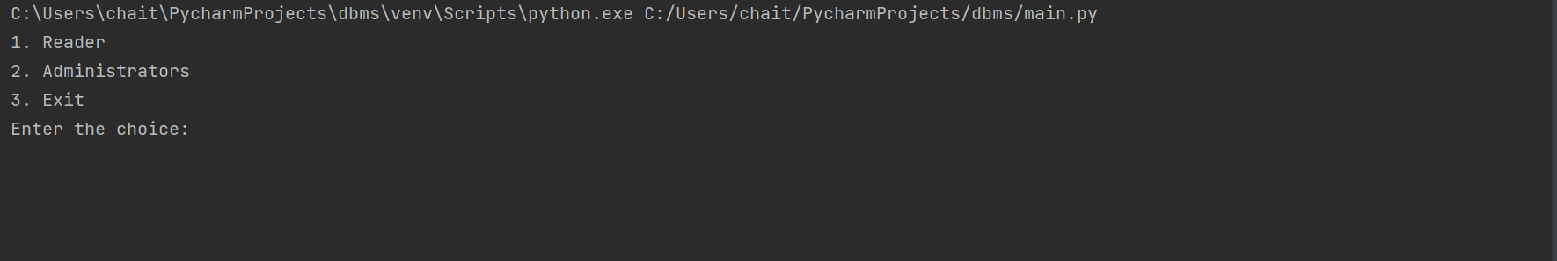

Selecting Reader option.

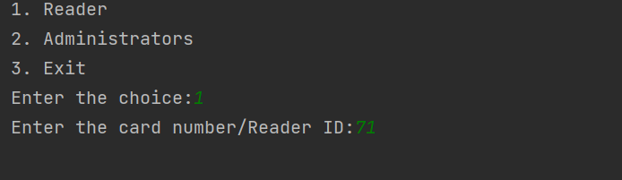

Inputting a card number which is not available:

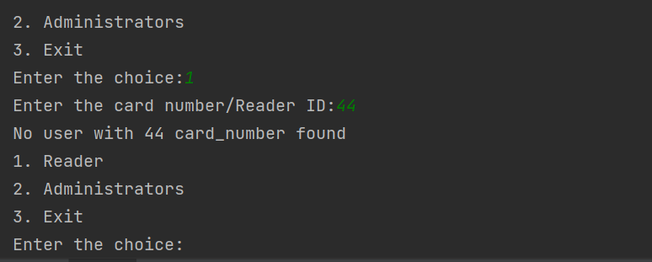

Reader Menu after successful validation of reader card.

(Assumption: Readers Card Number = RID)

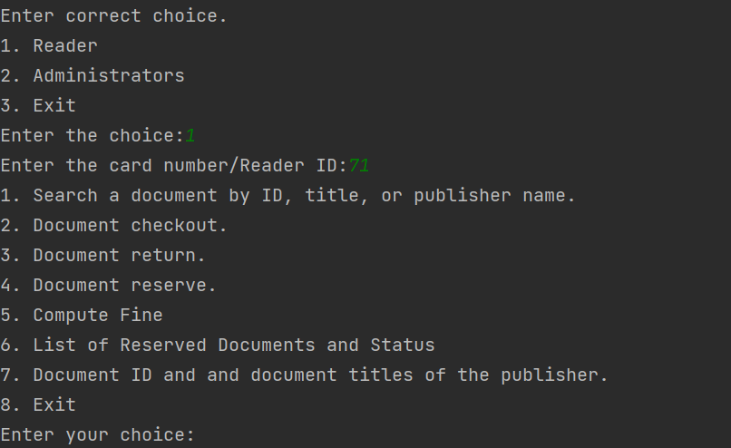

Reader Options:

Task 1: Search Document by ID:

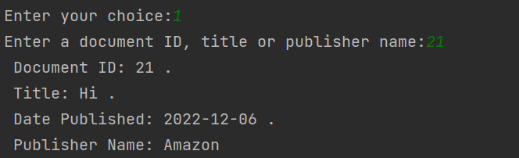

Search by Doc Title or publisher name:

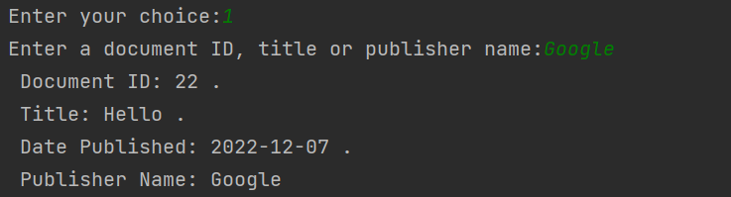

Task 2: Borrow a Document.

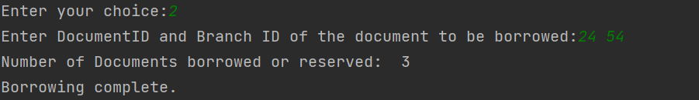

Will not allow a document to be borrowed if number of documents borrowed or reserved is greater than 10.

Trying to Borrow a document which is not available.

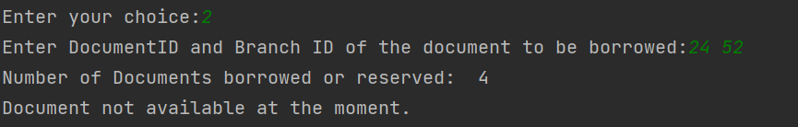

Task 3: Return a borrowed document.

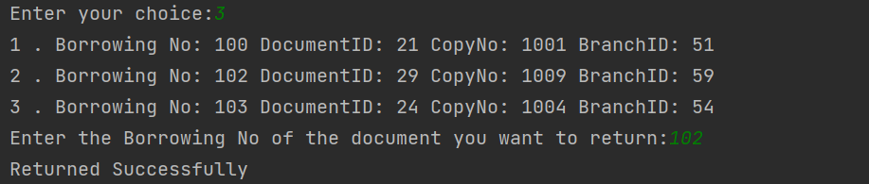

Task 4: Reserve a document

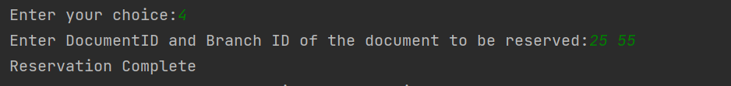

Trying to borrow a reserved book by different reader

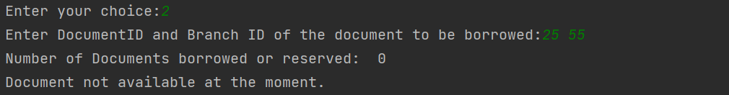

Borowing done by same reader who has reserved the book.

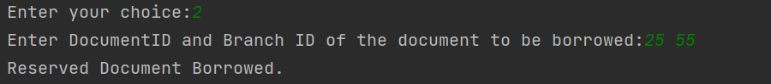

Task 5: Compute Fine

If no fine is on account:

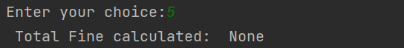

If fine exists on the reader account.

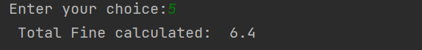

Task 6: Check reserved documents:

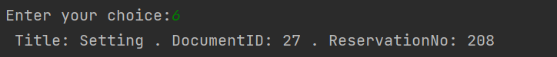

Task 7: Search Documents published by a given publisher

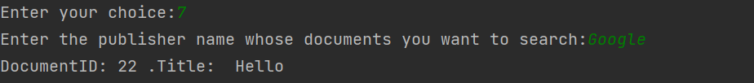

ADMIN TASKS:

Admin Verification:

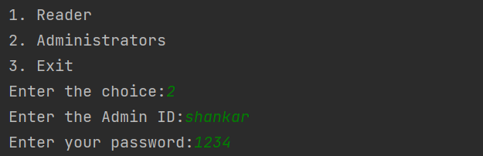

Admin Menu:

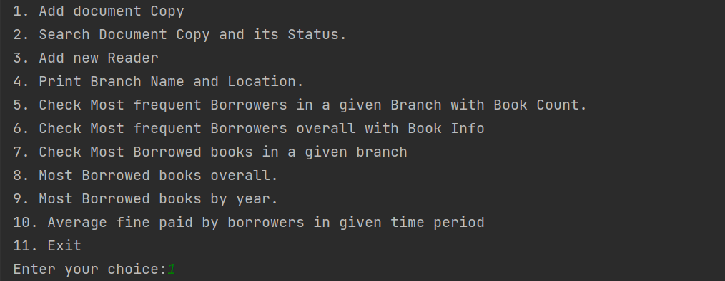

Task 1: Adding a copy for a doucment.

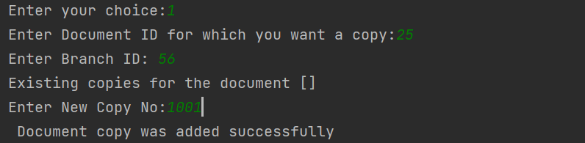

Task 2: Searching document and its status.

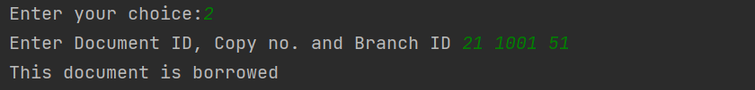

Task 3: Adding a new reader.

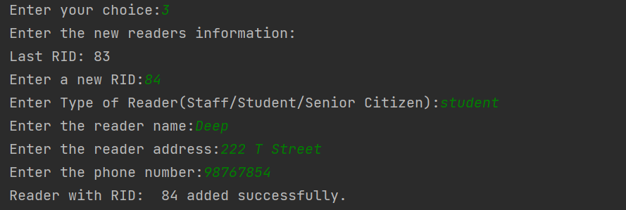

Task 4: Printing Branch No and location.

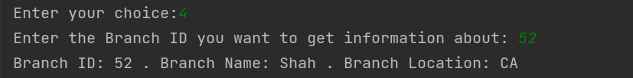

Task 5: Get Most frequent borrowers with book count given a branch.

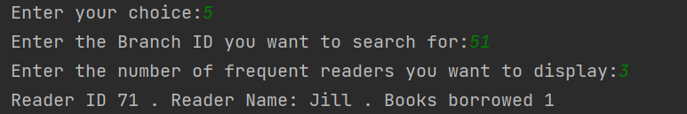

Task 6: Get most frequent borrowers with book count in entire library.

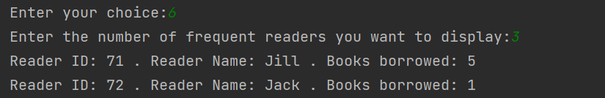

Task 7: Get details of most borrowed book in a given branch.

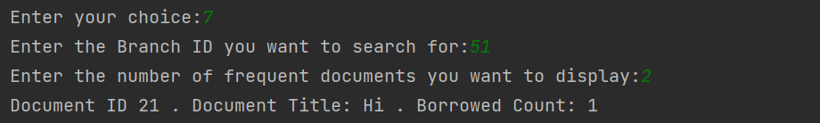

Task 8: Get detais of most borrowed book overall.

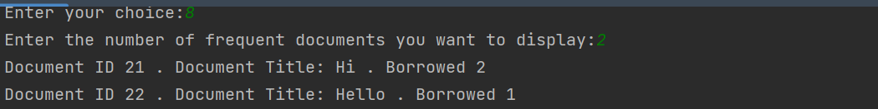

Task 9: Get most borrowed books by year.

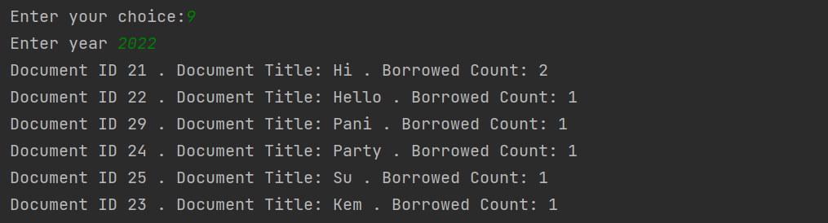

Task 10: Calculate average fine paid by borrowers.

